## **SCREEN SPECIFICATION**

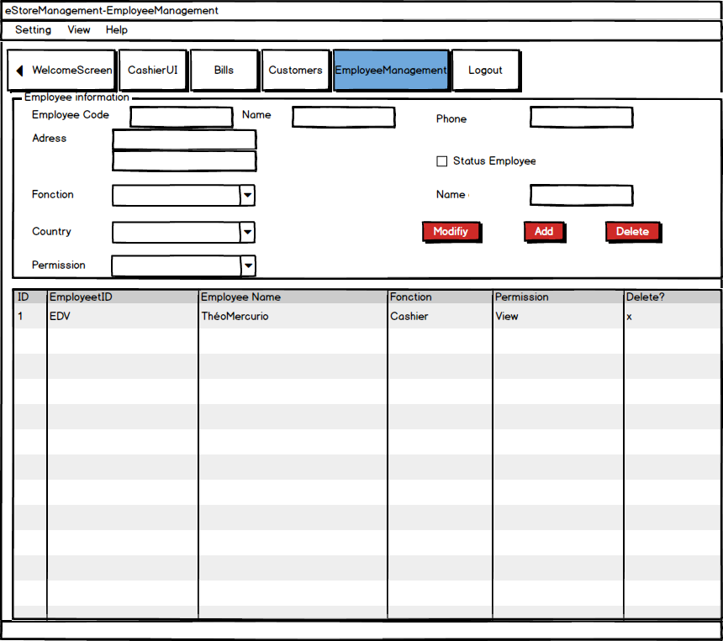EmployeeManagement

|  |  |  |
| --- | --- | --- |
| **Control** | **Opération** | **Function** |
| Menu | Click | Open Menu items |
| Logout | Click | Logout and go to login screen |
| Modify | Click | Modify Employee information |
| Add | Click | Add employee |
| Delete | Click | Delete Employee |
|  |  |  |

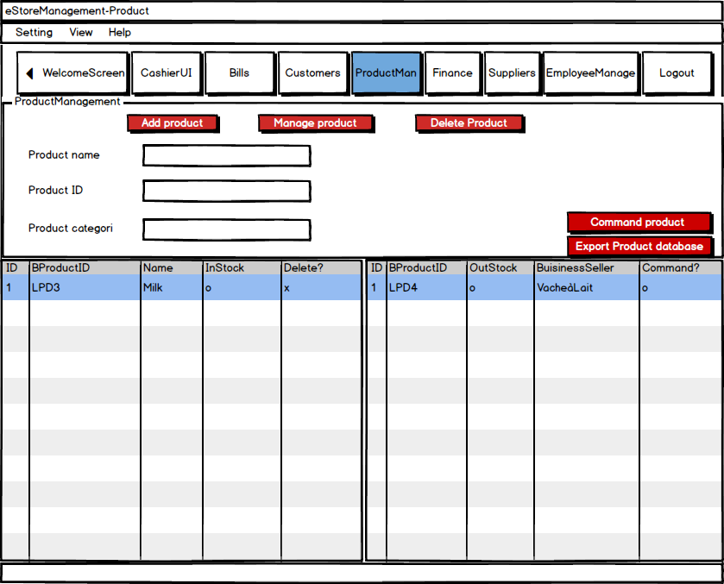

|  |  |  |
| --- | --- | --- |
| **Control** | **Opération** | **Function** |
| Menu | Click | Open menu items |
| Add product | Click | Add product to the list |
| Logout | Click | Return to the login screen |
| Manage Product | Click | Open the windows to manage the quantity of product |
| Delete product | Click | Delete a product from the list |
| Command product | Click | Open the list of products and the quantity to command the product which are not in Stock |
| Export product Database | Click | Export all the list product to another place |

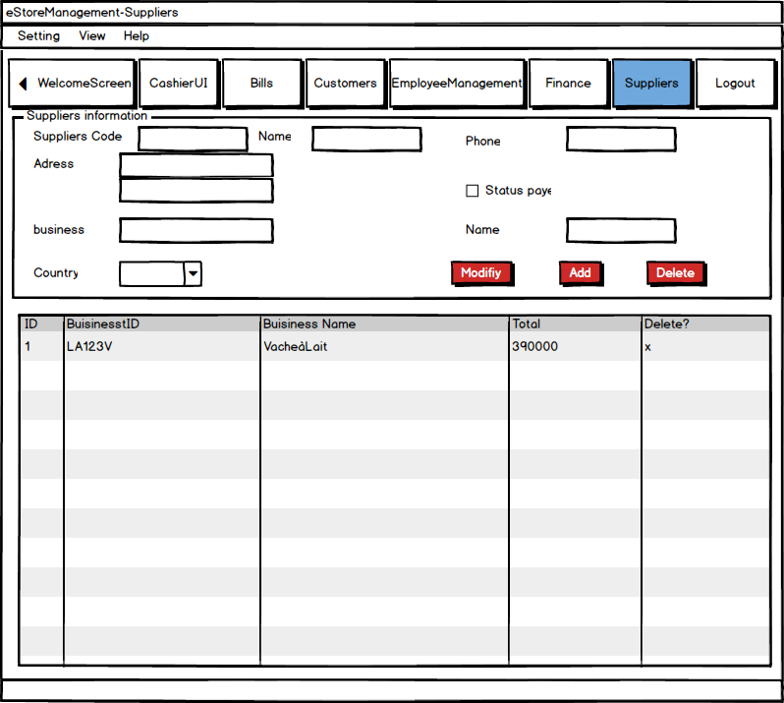

|  |  |  |
| --- | --- | --- |
| **Control** | **Operation** | **Function** |
| Menu | Click | Open menu items |
| Logout | Click | Return to the login screen |
| Add | Click | Add suppliers to the list |
| Modify | Click | Modify suppliers information |
| Delete | Click | Delete suppliers from the list |